Part III: Write an essay on this topic.

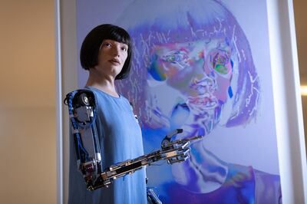
A.I. technology is already making waves in the art world. A.I. image generators can create stunning artworks based on text prompts, even copying the styles of famous artists. In 2022, while testifying before the House of Lords in the UK, Ai-Da, the robotic artist, said that “technology can be both a threat and an opportunity for artists.” What do you think? How is it a threat, and how is it an opportunity? Is it more one than the other? And do you consider what it creates to be art?

Of course technology is a threat to artists. Why? Because they already using some kind of technology and it is getting older and older each day. Take, for example, a photo-camera. Surely once it became accessible to regular people how many of them wanted a portrait? Over time demand for a photo of your face crushed the demand for a portrait. I’m sure that for many artists painting portraits was the main source of income. Obviously most of them eventually were put out of work. But there is a but. Someone did those photos, someone became an artist using new technology, and could not be one without it. With the AI it’s the same. Someone will be put out of work, because now there is a new, more optimal option. But someone would get a job if they know how to use AI to do art. I think it’s just a normal nature’s way. And I think it is art, just a new kind. It’s hard to accurately use a brush to paint. But it’s not so easy to accurately use AI to draw what you want it to draw. It is just a new way, and soon we will get used to it.

